
Department of Electrical & Electronics Engineering
Abdullah Gül University

EE3001 DSP Lab 4
Submitted on:
05.22.24
Submitted by:
Oğuzhan Alasulu

Lab Instructors: Oğuzhan Ayyıldız
Grade: / 100
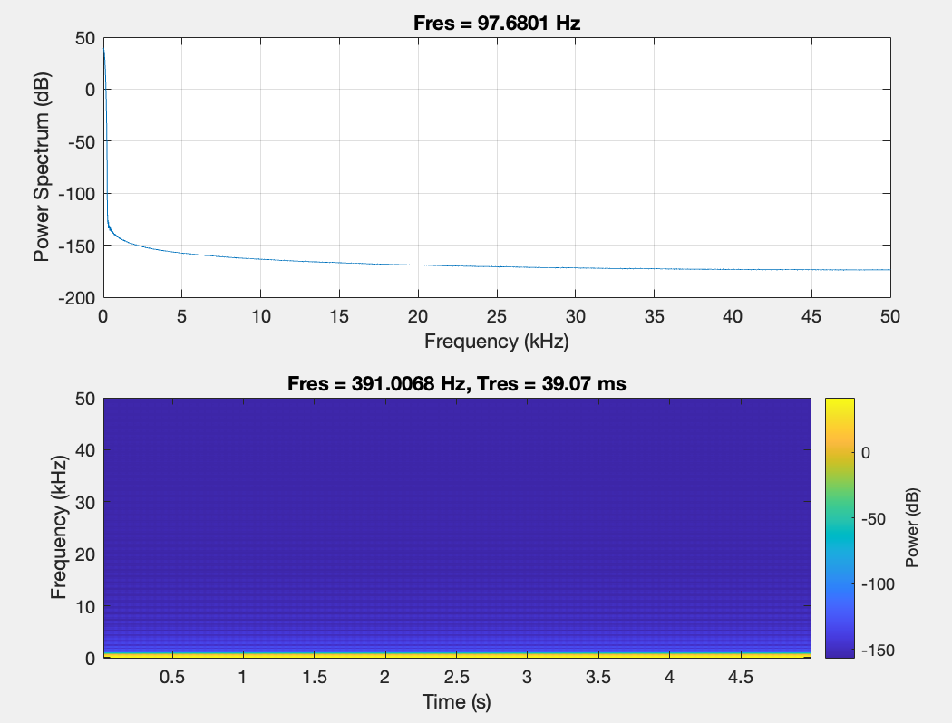
$$Figure.1 For 10Hz with 100 amplitude, with 100,000 Hz sampling rate$$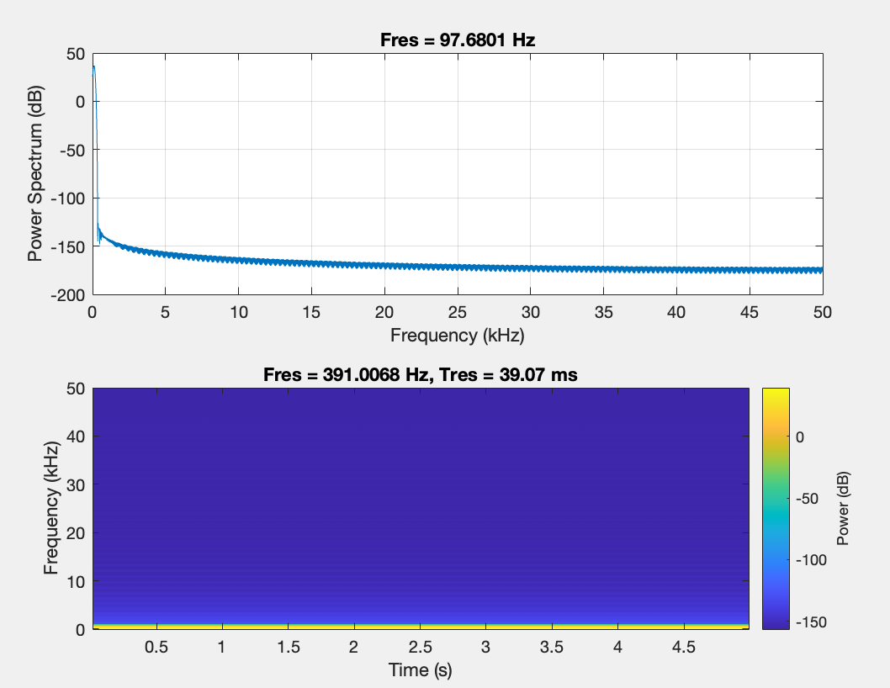$$Figure.2 For 100Hz with 100 amplitude, with 100,000 Hz sampling rate$$

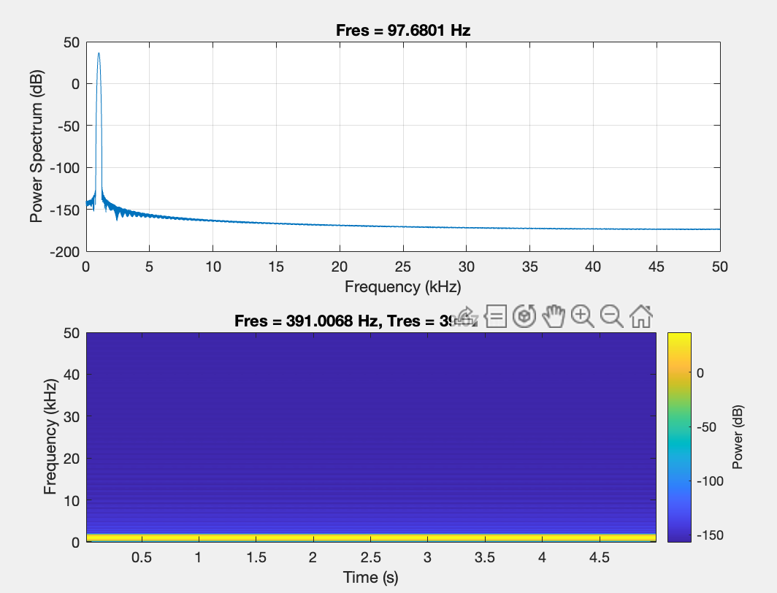
$$Figure.3 For 1kHz with 100 amplitude, with 100,000 Hz sampling rate$$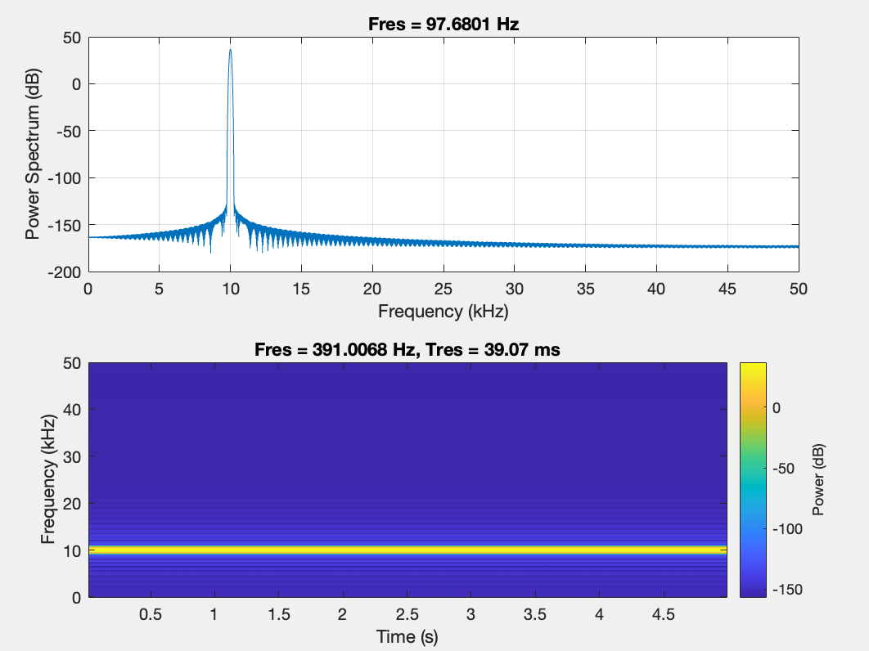$$Figure.4 For 10kHz with 100 amplitude, with 100,000 Hz sampling rate$$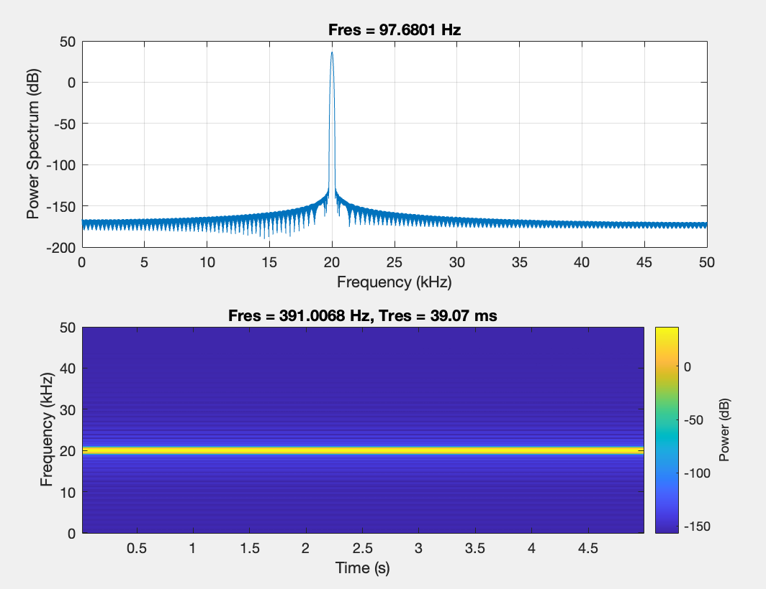$$Figure.5 For 20kHz with 100 amplitude, with 100,000 Hz sampling rate$$
The experiments exposed that frequency response plots and spectrograms shows the sound signal features. The frequency response graph shows how the amplitude of various frequency components differs, while the spectrogram explains the frequencies over time.

A single-frequency tone shows the frequency response, showing the existence of that specific frequency component. Through listening to the input sounds, it becomes obvious that they are produced at different frequencies. The presence of different frequencies in the frequency response graph is showing that a limitation applied by the sampling rate on frequency resolution. This limitation is directed by the sampling theorem, also known as the Nyquist theorem, which specifies the reproduce a signal, the sampling rate must be at least twice the signal of highest frequency. The Nyquist theorem shows that:
$$f_{s}≥2 x f_{max}$$
Where:
$$f_{s}=Sampling frequency$$
$$f_{max}=Max frequency$$
When the frequency of signal passes the Nyquist frequency, its higher components are changed as lower frequencies during sampling.
$$f_{alias}=f-Nxf_{s}$$
Where,
$N$= An integer
$F_{s}$ = Sapling Frequency

